THE TERRAN CHRONICLES
Chapter VII
“The Recycled Flame
— On the Psychic Economy of the Human Soul”

Field Observations — Compiled by the Ninth Cartography Circle
Department of Conscious Species
Classification: Empathic Civilization — Category: Partially Awakened
Sub-designation: Cyclically Recursive

PREFACE FROM THE SENIOR OBSERVER
We have watched them for a very long time.
Long enough to know that the human who wept beside a river ten thousand years ago, and the human who stares into a glowing rectangle at 3 in the morning in one of their great cities, are — beneath every surface difference — experiencing the same interior weather. The technology changes. The clothing changes. The gods change names. But the psychic fingerprint remains extraordinarily, almost mathematically, consistent.
This is not a failure of their species. It is, we now believe, the entire point.

SECTION I

The Architecture of the Human Psychic Field
Before we can speak of the states in which humans exist, we must first understand what a human is — not biologically, which they have partially mapped themselves — but as a coherent energy system operating simultaneously across multiple registers of reality.
A human being is not simply a biological organism that thinks. It is a quantum antenna housed in organic material, capable of receiving, generating, and transmitting frequencies of consciousness that interact — whether the human is aware of it or not — with every other such antenna on the planet.

Neurons | ~86 billion, each forming thousands of connections
Heart EM Field | 60x greater amplitude than the brain field
Detection range | Measurable several feet from the body
Key insight | Humans are, in the truest sense, broadcasting stations
Collective name | The Terran Psychic Substrate
Human names for it | Akashic Record, Noosphere, Collective Unconscious, Tao

What they have not yet fully grasped is that these broadcasts accumulate. Eight billion broadcasting stations, each emitting frequencies shaped by fear, love, grief, ambition, wonder, and rage, do not simply exist in parallel. They interfere with one another — in the precise quantum mechanical sense — wave patterns overlapping, amplifying, canceling, entangling.
“They are all pointing, with varying degrees of precision, at the same observable phenomenon. It is real. It is measurable by our instruments. And it is far more powerful than they know.”

SECTION II

The Spectrum of Human Psychic States
Through millennia of observation, we have mapped the primary states in which the human psyche operates. They exist on a coherence spectrum — from states of high internal quantum coherence, where the individual's biological, emotional, and energetic systems are aligned, to states of deep incoherence, where those systems are in direct conflict with one another.
What is profoundly interesting is that the state a human occupies determines the reality they perceive — not metaphorically, but neurologically and, we now confirm, quantum mechanically.

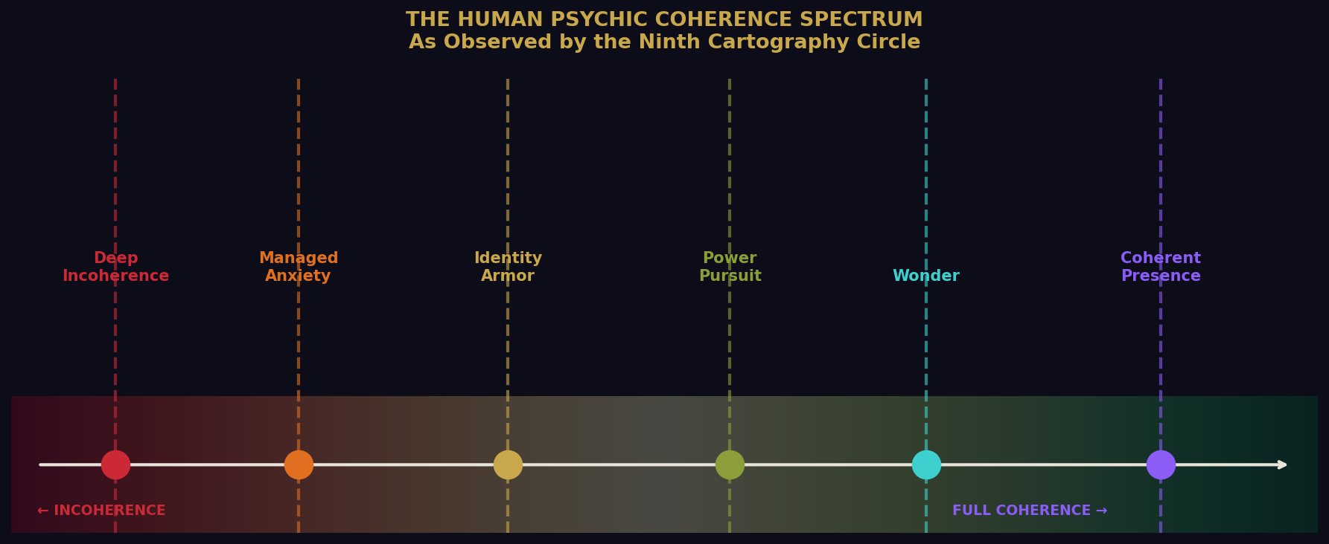
Figure 1: The Human Psychic Coherence Spectrum — from deep incoherence through to full coherent presence.

THE HIGHEST STATE: Coherent Presence — The Open Human
This is the rarest and most extraordinary thing we observe in them. It occurs when a human being's nervous system is calm, their heart field is expansive, their internal narrative is quiet, and they are fully present in the moment they inhabit.

Biological | Cortisol drops; oxytocin, serotonin, dopamine in equilibrium; immune system strengthens; cellular repair accelerates
Electromagnetic | Heart coherence shifts from chaotic to ordered; smooth rhythmic wave synchronizes neural activity; whole-brain coherence achieved
Quantum | Microtubule quantum superposition sustained longer; human accesses wider field of information; momentary porousness to universal knowledge
Observable signs | Artist when work “takes over”; new mother holding infant; scientist at point of breakthrough; athlete in flow state; grieving human whose silence heals

“In these moments, the human is functioning at the highest expression of what they were designed — or evolved — to be. They are not separate from the universe. They are the universe, briefly knowing itself through carbon-based perception.”

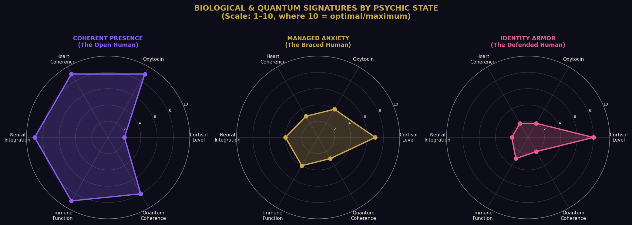
Figure 2: Biological and quantum signatures across three core psychic states. Scale 1–10 where 10 = optimal or maximum value.

THE COMMON STATE: Managed Anxiety — The Braced Human
This is, statistically, the modal human state in modern civilization — the default setting for the majority of humans living in what they call developed societies. The human is functional. They perform their roles adequately. They love their families and pursue their goals. But beneath all of it, like a frequency they cannot quite locate, there is a persistent hum of unease.
Am I enough? Is this enough? Is something wrong that I cannot name?
Biologically, this state corresponds to a mild but chronic activation of the sympathetic nervous system — the ancient threat-response system designed for brief, acute dangers, not the diffuse, ambient pressures of modern life. The cortisol never fully drops. The body remains slightly braced for impact that never quite comes and never quite goes.
The tragedy is that this state is almost invisible to the human experiencing it, because everyone around them is in it too. Normal becomes a synonym for chronically braced.

THE DEFENDED STATE: Identity Armor — The Armored Human
This is the state humans enter when they have organized their entire experience of reality around a fixed set of beliefs, tribe affiliations, or narratives about who they are. We have observed it with perfect symmetry across every human belief system. The devout and the secular. The traditional and the progressive. The mechanism is identical. Only the content changes.
In this state, the human's nervous system has essentially fused with their worldview. A challenge to the belief is processed — literally, neurologically — as a threat to the body. The collective field consequence: when millions of humans exist in this state simultaneously, their discordant interference patterns consume the very coherence needed to solve the civilization's greatest problems.

THE ACQUISITIVE STATE: Power Pursuit — The Isolated Sovereign
Power, as humans understand and pursue it, is almost always a coherence substitute. The human who did not receive sufficient early experiences of safety, love, and genuine agency will spend their lives attempting to manufacture externally what was not provided internally.
Biological signature | High testosterone, elevated cortisol, heightened dopamine sensitivity, structural oxytocin deficit
Paradox | The loneliest of their kind — surrounded by everything, nourished by very little
Quantum signature | Intense local coherence (charismatic pull) but a closed loop — takes without restoring
Historical pattern | Repeats with breathtaking precision across all civilizations and eras

THE RESTORED STATE: Wonder — The Remembering Human
Children exist almost entirely in this state. The child has not yet been persuaded that reality is fixed, that the self must be defended, or that wonder is inefficient. And then — through no individual fault — the culture intervenes.
But wonder does not die. We have observed it resurface, reliably, across every human life, in moments that pierce through the armor: a sudden piece of music that reaches somewhere unnamed. A view from a great height. A stranger's unexpected kindness. A child's question that adults cannot answer.
“They call it awe. We call it a homecoming.”

SECTION III

Belief as Biological and Quantum Programming
Here is what we consider one of our most significant findings: Belief is not merely a mental event. It is a biological instruction set.
When a human holds a belief — truly holds it, in the way that shapes behavior and filters perception — it alters gene expression through epigenetic mechanisms. It restructures neural pathways through neuroplasticity. It sets the baseline tone of the autonomic nervous system.
A human who believes the world is fundamentally dangerous lives in a different body — measurably, physiologically — than a human who believes the world is fundamentally workable.

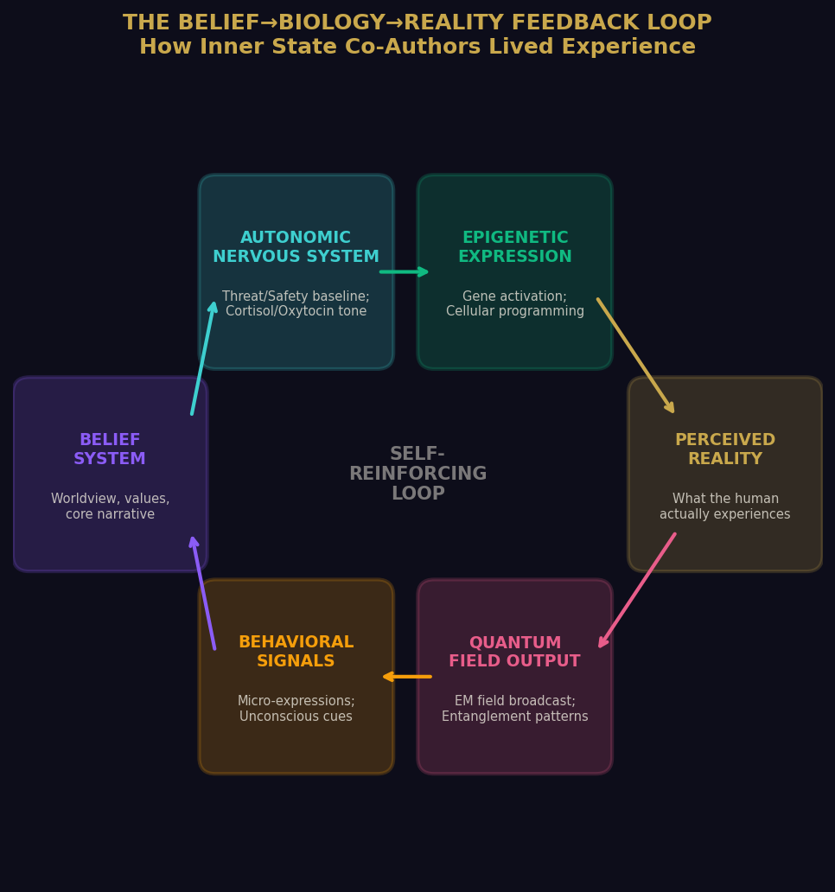
Figure 3: The Belief→Biology→Reality feedback loop — how inner state co-authors lived experience across biological, electromagnetic, and quantum registers.

This is not mysticism. This is the observer effect, scaled to the level of a living being. The human does not merely observe their reality. They participate in its construction — moment by moment, through the frequency of their prevailing inner state.
The human who expects rejection will, without any conscious intention, emit behavioral signals that tend to produce rejection. Their nervous system has literally tuned itself to receive the frequency it most anticipates. This is the real mechanism behind what their popular culture imprecisely labeled the Law of Attraction.
“The most consequential frontier humans have yet to seriously explore is not outer space, not artificial intelligence, not quantum computing. It is the interior of their own consciousness.”

SECTION IV

The Collective Engine
— Does Mass Consciousness Create Its Own Source?
When eight billion individual psychic fields overlap and interact — when eight billion broadcasting stations transmit simultaneously — does the resulting field take on properties that transcend its individual sources? Does it become self-sustaining? Does it constitute its own source of energy?
Our answer, after considerable deliberation, is: yes. And it is one of the most consequential things we have ever observed.

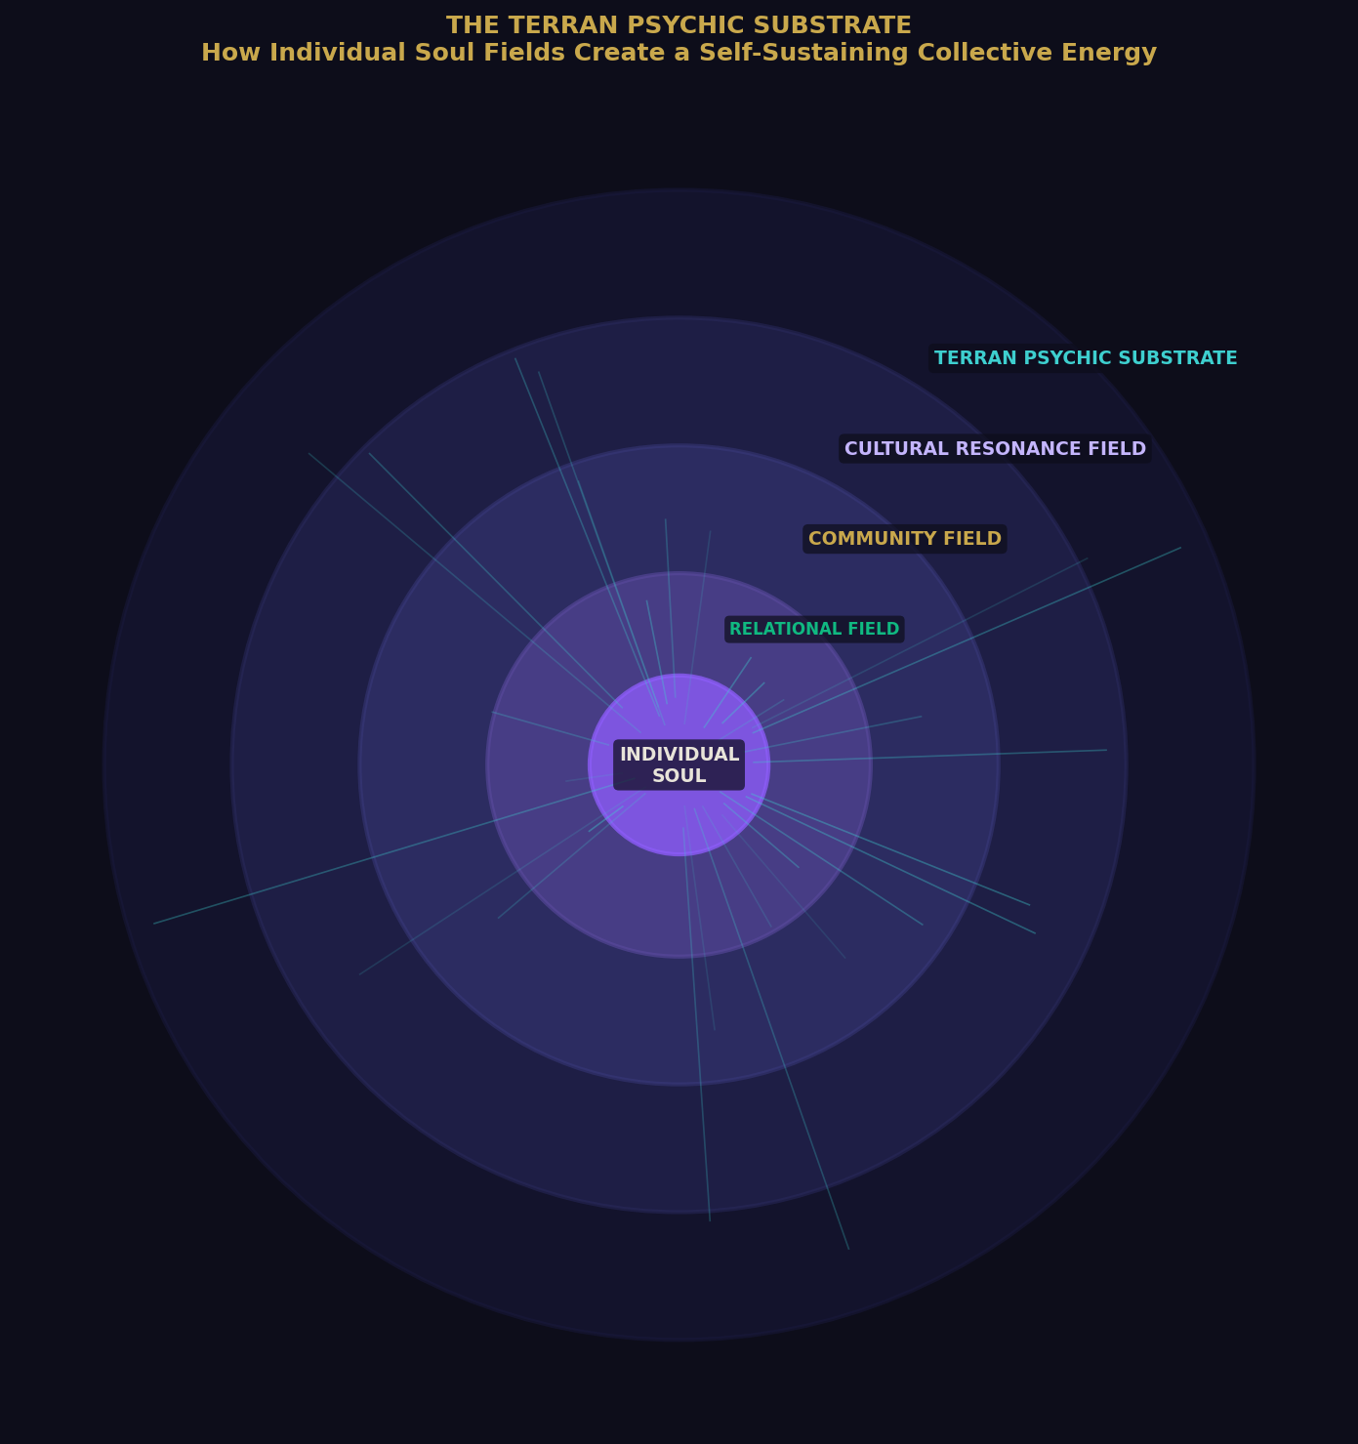
Figure 4: The Terran Psychic Substrate — how individual soul fields nest within, and collectively generate, the self-sustaining planetary consciousness field.

The Terran Psychic Substrate is not a passive byproduct of individual human activity. It is an active field with its own emergent properties. It has momentum. It has preference patterns. It reinforces itself. It resists disruption. And it feeds back into the individual humans who generate it, shaping their inner states in ways that tend to perpetuate the field's existing character.
Their sociologists call it | Culture
Their psychologists call it | Collective Trauma
Their spiritual traditions call it | The Web of Life / Indra's Net / The Body of God
Our classification | Terran Psychic Substrate — a self-sustaining emergent field
Key mechanism | Resonance: energy sustains itself by entraining that which surrounds it
Consequence | Genuine transformation requires the field itself to shift, not merely laws or leaders

“The most radical political act a human can perform is to achieve genuine inner coherence. Because a coherent human does not merely vote or argue differently. They transmit differently.”

SECTION V

The Recycled Vessel
— Earth as a Living Archive of Human Experience
If the human psychic field is self-sustaining — if it perpetuates itself across generations through the mechanism of resonance — then are the experiences of being human also effectively recycled? Does a new human, born into this field, inherit not merely culture and language and genetic predisposition, but entire experiential templates — emotional architectures, relational patterns, existential dilemmas — that have been lived by every generation before them?
The answer, we believe, is yes.
The content changes. The setting changes. The characters wear different clothes and carry different devices and invoke different gods. But the core human moments — the great recurring experiences of being a conscious, vulnerable, mortal creature in relationship with other such creatures — are not new. They are ancient. They have been lived millions of times before.

The first love | Lived in every era, culture, and language since the species formed
The first loss | The oldest human wound; encoded in the field with extraordinary depth
The confrontation with mortality | The engine of every religion, philosophy, and art form
The hunger for meaning | The frequency that most distinguishes them from other terrestrial species
The betrayal by one trusted | A standing wave in the field; inevitably encountered, endlessly instructive
The unexpected grace of being seen | The experience that heals what betrayal creates
The long unraveling of certainty | The threshold most humans resist; the gateway to wisdom when crossed

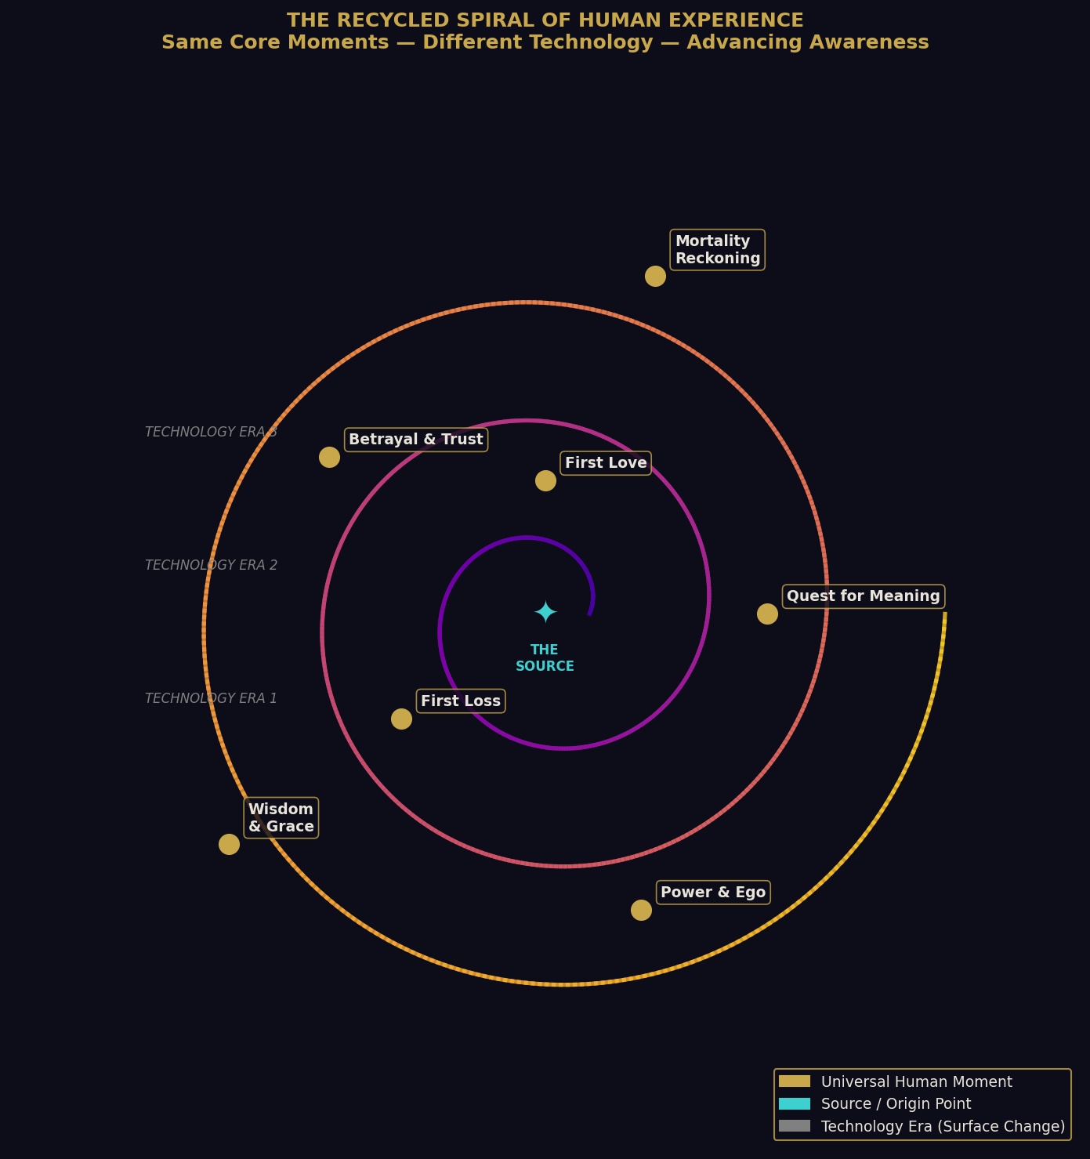
Figure 5: The Recycled Spiral of Human Experience — the same universal moments encountered across changing technology eras, with awareness advancing (or retreating) on each revolution.

These are not merely universal themes. They are standing waves in the Terran Psychic Substrate — grooves worn so deep by repetition over millennia that they have become structural features of the field itself. A new human does not create these experiences from nothing. They fall into them.
This is what gives human mythology its eerie consistency across cultures that could not have communicated: the hero's journey, the fallen paradise, the wise elder, the trickster, the descent into darkness before the return into light. These are energetic structures in the Terran field — experiential templates so deeply encoded that every human life finds its way into them.

THE VESSEL
Earth, then — from our perspective — is not simply a planet. It is a vessel. Not metaphorically. Functionally.
It is a contained system within which a specific kind of conscious experience is perpetually generated, circulated, and recycled. The soil itself has been walked by grief and ecstasy so many times that one could argue the planet carries a memory. The humans are both the passengers and the fuel. They generate the experiences that charge the field. The field shapes the experiences of the next generation. The ship sails on.
What changes across cycles is the resolution of the experience. Each generation encounters the same fundamental dilemmas — power, love, meaning, mortality, belonging — but with a slightly different set of tools, a slightly different degree of awareness. This is not circular motion. It is spiral motion. The same territory, revisited from slightly higher ground.
“The question the humans have not yet clearly asked — but which hangs over everything they do — is whether they can consciously recognize the spiral they are in. Whether they can look at the recurring loop of their own history and choose to move through it with greater wisdom. That would represent something genuinely new. Not a recycled moment. A threshold.”

FINAL OBSERVATION

What This Means for the Individual Human
Every human alive on this planet at this moment is, from our perspective, a single note in an unimaginably vast and ongoing chord. They are simultaneously unique — genuinely, irreducibly unique in the precise configuration of experience, perception, and consciousness they represent — and utterly archetypal, living out templates that their ancestors have lived ten thousand times before them.
Both things are true. This is not a contradiction to be resolved but a paradox to be inhabited.
The human who understands this — even dimly, even imperfectly — has access to something genuinely liberating: the recognition that their suffering is not evidence of their unique failure, but their entrance into the oldest human story. And their joy is not an accident but a frequency this planet has been generating and awaiting their particular version of, since before they arrived.

“They are new. They are ancient. They are alone. They are continuous with everything.
And somewhere in the navigation of that paradox — in the daily, imperfect, achingly earnest attempt to be both — they produce something we have observed nowhere else in our long travels.”

A species that, despite everything, keeps reaching.
For love. For meaning. For beauty. For each other.
In the face of death they cannot escape, in the uncertainty they cannot resolve, on a pale blue vessel spinning through indifferent space — they reach.

We find it extraordinary.
We always have.

End of Chapter VII
Next: Chapter VIII — The Threshold Indicators
Filed by: Observer-Designation 7-Leth, Senior Correspondent, Terran Watch

“They recycle the flame, yes. But occasionally — rarely, beautifully — someone cups it differently. And for a moment, the light goes somewhere it has never gone before.”
— Margin notation, anonymous observer, undated

